DIGITAL PHOTOGRAPHY SYLLABUS
Point Pleasant Borough High School

Instructor: Mrs. Cook
kcook@pointpleasant.k12.nj.us
mrs-cook.weeby.com/digital-photo.html
Room: A-3

Course Description
This course will help students become well rounded in the fundamentals of digital photography. This class will be a “technical” art class: in other words, principles of art and design will be the focus, but these areas will be taught in the context of acquiring the technical skills needed to use digital equipment creatively. Anyone can take snapshots with a point and shoot camera; students in the class will go far beyond this to learn how to correctly use a digital SLR camera as a tool to express feelings and ideas, and how to compose a picture carefully so that it is meaningful to any viewer.

Four areas of instruction will be emphasized: compositional strategies, camera fundamentals, elements and principles of design, and photo editing and manipulation using Photoshop. Students will, generally, receive basic instruction, demonstration, and see samples of the desired outcomes, at the beginning of each period. They will be allowed to go outside and shoot assignments, based on what they are learning. The end of each class will be spent editing, critiquing and posting finished work to the classroom social networking site, Edmodo.com.

In this class we will cover:

  - History of Photography
  - Compositional strategies
  - Acquiring technical skill and understanding camera functions.
  - Elements and Principles of Design
  - Exploration of different subject matter
  - Photo editing and creative manipulation using Adobe Photoshop
  - Art criticism

NEEDS AND RESOURCES

Learning Outcomes
To successfully complete this course, students must:
  - Show up in class, on time
  - Pass course quizzes
  - Complete assignments by given deadlines
  - Cooperate with other students and staff to increase learning potential
  - Take and edit photos successfully using digital cameras and photo editing software
  - Thoughtfully analyze and critique one’s own work as well as that of peer’s
  - Upload final edited photo with written critique at end of class each day

Required Materials
Class Resources

Class Website
The class website can be found at mrs-cook.weebly.com/digital-photo.html. It has been set up to provide valuable course information to both students and parents. The “Digital Photography Homepage” serves as a teacher blog, where I will post any important class updates, changed due dates, art contest information, etc.

Schoology.com
Schoology.com is a social learning platform that provides a safe way for students and teachers to connect and collaborate. Students will log-in to Schoology.com each day to see the day’s assignment as well as directly access all learning materials needed for each lesson such as teacher PowerPoint presentations, hand-outs, instructions, visual aids, etc. Students will use Schoology.com to turn-in assignments each day, as well as share their work and ideas with fellow classmates. Parents can also access Schoology with a special parent code that will be sent out at the beginning of the school year.

POLICIES AND PROCEDURES

General Rules
All School District Policies apply. Digital Photography specific rules include:

- Students shall be subject to the rules and regulations set forth in the Board Policy addressing Pupil Discipline/Code of Conduct and Harassment, Intimidation, and Bullying.
- Students will conduct themselves appropriately when participating on Schoology.com. This includes:
  - No profanity or inappropriate language or images on Schoology.com. No obscene, profane, defamatory, libelous, threatening, harassing, abusive, hateful, embarrassing, disrespectful and/or discriminatory comments on the Schoology.com
  - No acronyms, symbols or any abbreviated forms of any words on Schoology.com.
  - Postings will be limited to class-related materials only. Students will only post factually correct information, and will try to spell everything correctly.
  - Students will keep their passwords secure, and will not permit and/or facilitate any other individual’s access to their account. Students will be responsible for anything posted in their name. Students will not use any other individual’s name or password access the site.

Participating on Schoology.com is a privilege, not a right. Student’s postings may be removed at any time and for any reason. Participation in or access to the blog site shall not be considered a substitute for classroom participation.

- On hall pass for Digital Photography, students will conduct themselves appropriately. This includes:
  - Staying with their groups, not splitting up for ANY reason.
  - Staying on school property (no guardrail!) and staying within areas allowed for student access only.
  - Keeping your voice down, not disturbing any other classes or students.
  - Not touching any objects in other classrooms.
  - Not taking photographs of anyone without their permission.

Students who fail to follow these or any additional guidelines may be subject to the revocation of their computer and/or hall pass use and may be removed from the Digital Photography class (with loss of credit).

4. Students will treat class cameras with care and use them only as directed. This includes:
- Handling camera with care at all times, no swinging camera around or handling parts forcefully.
- Always wearing the neck strap when handling camera.
- Never touching or removing the camera lens. This includes cleaning. The teacher is the only person authorized to clean the camera lens if it is dirty.
- Cameras should never be placed in a purse or backpack.
- Cameras should never be near food, drinks, water or dirt/sand.
- Cameras should only be used by the specific student(s) they are assigned to. Students should never allow another student to touch/hold/use camera.
- The same care should be used when handling camera batteries and SD cards.

Students who fail to follow these or any other additional guidelines set forth by teacher may be subject to loss of DSLR camera privileges.

Grading Policies:
Photo assignments will be graded using the rubric, found below. 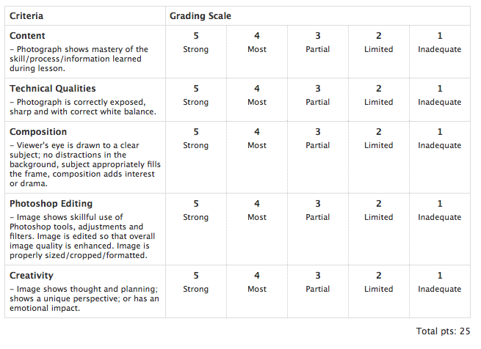

Class Participation
Class participation counts as 15% of the final grade. Participation is graded based on students’ ability to meet the following criteria:

  - Good use of class time, always on task.
  - Appropriate conduct when out on photo assignments using hall pass (see rules above)
  - Appropriate conduct on and use of blog (see rules above)
  - Work is completed with care and maximum effort
  - Student is attentive during lectures, taking notes when directed
  - Student participates in class discussions and critiques.

Missed Assignments
It is the STUDENT’S RESPONSIBILITY to see me to make up missed work when absent. Missed presentations, lessons and assignments can always be accessed on the class website (mrs-cook.weebly.com) and Schoology.com. Students are expected to find out what they have missed and look over all missed PowerPoint presentations, instructions etc. when they are absent. Time allowed to turn in missed work = number of days of excused absence. After that period of time, a failing grade will be given. Students may make an appointment to come and see me before school, during school or after school if they need more time to complete work.

Contact Information
Students are urged to come and speak with me in person whenever they can. Outside of class time, I can usually be found in one of my two classrooms: A3 or A11. Parents and students are also encouraged to e-mail me with any questions or concerns. You can reach me at kcook@pointpleasant.k12.nj.us.

